

Hey, go on and read my story!!

All About Me!!!

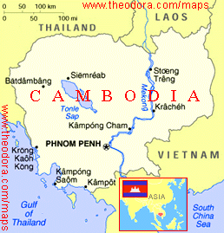

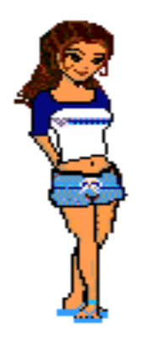Hey, I’m Kalyan S. I’m 13 years old. I come from Cambodia. Cambodia is next to Thailand, if you know Thailand. I’m a teenager like you! You might want to know about my life. You also might want to know what it is like to be a teenager. So, go on and read about me, what I want to improve, my dreams, my favorite things, my friends, where I live, and my thoughts and questions.

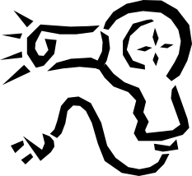
About Me

I have long hair. My hair color is like black a bit, red a bit, and blonde a bit. I like to do different hairstyles. I’m tall; my skin color is tan, and my eye color is brown.



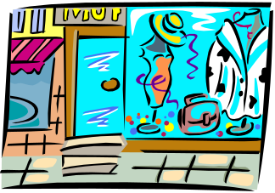
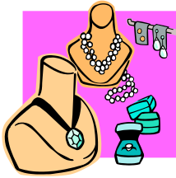

Sometimes I’m funny, sometimes I’m boring, sometimes I like to talk a lot, and sometimes I go so crazy. I’m nice to other people. I don’t hit them or cut their hair just because they’re prettier than me or say bad words to my friends. What I dislike about myself is that I’m the eldest. What I like about myself is that I get to go shopping with my mom more than my sister does, and I get an allowance bigger than my sister and brother’s. I consider my greatest achievement that I have done something really special for my mom (I will talk about this later). My goals at school are to finish school and graduate from school, so when I go to work anywhere I could show my diploma, and they will let me work. I could change my life by changing the way I act, the things I like to do, and other things. My strength is that sometimes I can handle something really important in my life.


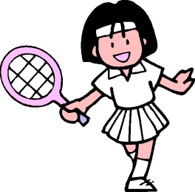
 My most marked characteristic is that I’m really good at sports. I’m really good at art also; I like sports and art a lot. I don’t tell my friends that I’m good, because they might say that I’m such a show off, and I don’t like being a show off.
I like sport a lot. My favorite sports are volleyball and soccer.

I am always myself and do not fake my behavior. The thing that really makes me angry is when my baby brother cries so loud that I can’t concentrate on my homework. The quality I like most in women is that they are more affectionate and caring than men, and they are also smarter than men. The one million dollar questions I would like to ask is: “Why are there bad people and not only good people on earth? And how many people believe in curses and ghosts?” My greatest fear is that I won’t be a true person, and that I will be scared to do anything really important in my life.

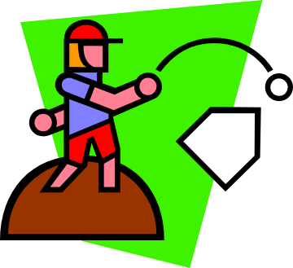
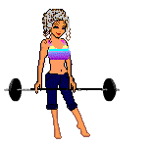





What I Want to Improve

I would like to become a better sister to my sister and brothers, and I would like to be smarter. I need to improve a lot of things in this world. Like I should more understand my sister and brothers. The one thing that I would do to improve this world is to make it a better place for the poor, I should also show my sister that I love her so much, more than anyone else, and my brothers too.
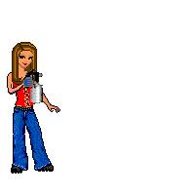
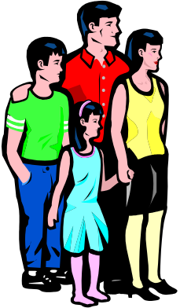
Happy Birthday Kani!!!!




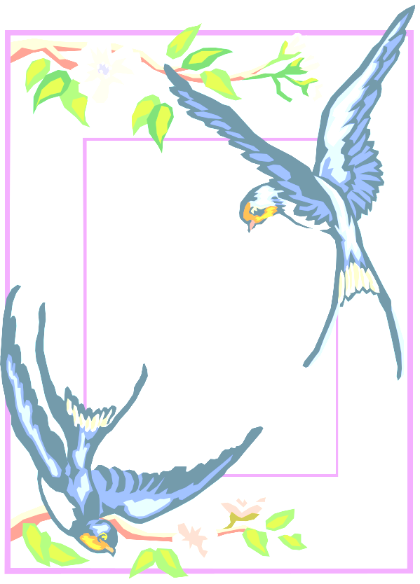

These are my
dreams!

My Dreams



My dreams are to be smart, to know how to think, what to do for my family so that we would all be happy. I have lots of dreams about my life. I would like to be a famous singer who knows how to deal with people. The dream I’ve had more than once, is the one that has a ghost all covered in black, and the his face is so creepy. Every time I say, “I’m not scared of you,” the ghost keeps on coming after me and scares me so badly. When I wake up in the morning, I am so scared and sweating. The ghost always comes when I tell him that I’m not scared of him. I just don’t understand why. I have had that dream like 10 times already; it doesn’t come like every night, only once or
I want to be smarter!

twice a week.



I like singing and I like mermaids!


My Favorite Things


I have so many favorite songs; I can name a few I like: “I’m a Slave 4 You”, “Complicated”, and “A Super Star.” I like “I’m a Slave 4 You” because I sound like the singer a lot. I like “Complicated” because some of my friends are like that; and I like “A Super Star” because it’s a nice song. My favorite days of the week are Friday and Monday; I like Friday because we don’t have school on the next day. My favorite month is June because my birthday is in June.



My Friends

The topics that I usually like to talk about with friends are about girls and secret stuff. Yes, there’s a friend who hurt me and I have not forgiven her, because she still doesn’t know what she did wrong. Another friend also hurt me, but I have forgiven her because she knows what she did wrong.



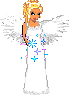

Where I live

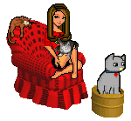
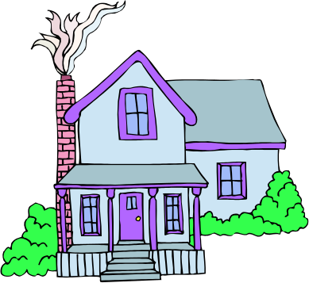
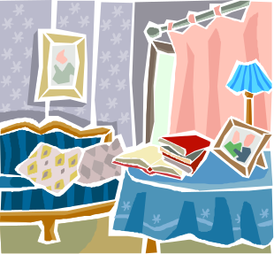Right now, I live in Lebanon; before, I lived in Russia and Cambodia. In Lebanon we don’t have our own house; we have rented one. We have to pay the rent every year, but the house is really nice. My room is beautiful, I love it and I’m not going to share it with my sister or my brother. My room has a big bed, a makeup table, and closets for my clothes. And I have two small tables. I put them on each side of my bed. What I like about my room is that it’s a big one and I have lots of toys for sleeping. I hug them every night before I go to sleep. It’s really nice.

This is where I lived.





My Thoughts and Questions

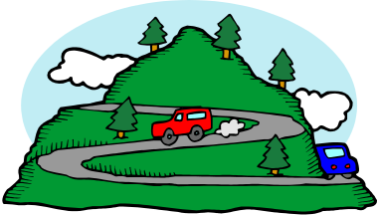
About humanity, I generally think it’s really nice when you need to go to school if you are young and if you are an adult you have to work a lot. Sometimes life is crazy. If I had a million dollars to spend, I would spend it in a good way. The best advice that I have ever received is that I should sing for the talent show. Sometimes I had weird things happen to me, like the day I had to go to Faqra with my classmates. I felt like this was not the right day to go to Faqra. When I got on the bus, the bus had taken us almost there, and then we were stuck in the middle of the road in the snow, so we went back down.

Conclusion

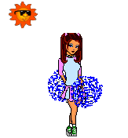
So, now, you know a lot about me, what I need to progress in, my hopes, my most wanted things, the people I hang out with, where I reside, and my views about life. But that’s not all! There are more exciting things about my family, my hobbies, and other things. So, what do you think might be in the next essay? Go, read it, and find out!

